Overview of WBS
Task Categories
What is a WBS?
Simple projects like grocery shopping might not need a plan to accomplish the project. When grocery shopping, most people will make of list of the items that need to purchase. Everything on the list is purchased and the project is completed. Not all projects are this simple.
Larger projects like building a house will require more planning and detail to accomplish the goals of the project. More tasks will be required, more detail and organization to the detail. More data will be accumulated regarding how the project was performed. To accomplish these types of projects, a work breakdown structure or WBS will be required.
The WBS is a hierachitcal structure much like an outline list. This structure will contain the work of the project. How it is organized will determine how effective and helpful the project schedule will be. Within the structure will be titles and well as details. The structure will also contain goal points or milestones to help manage target dates.
Consider the WBS of a project the same as the foundation for a building. Without a stable foundation the building will not be stable. Having a stable or well-planned WBS will be an asset to the performance of a project. Having an unstable WBS may adversely affect the management of the project schedule.
Creating the Work Breakdown Structure
Once the tasks of the project are established, the next step is to enter the tasks into the project schedule and create a WBS structure. Entering tasks may be a manual keying process or they may be imported from a SharePoint list (Project 2010 Pro only), an Excel workbook, an Outlook task list or a Word document. Tasks may also be copy and pasted into project schedules. This lesson addresses the manual entering of tasks into the project schedule.
In this lesson, we will discuss:
Entering tasks
The Task Information Form
Outlining tasks into a WBS Hierarchy
Displaying WBS code values
Customizing WBS code numbers
Entering Tasks
Entering tasks into Project 2010 is as easy as typing the task name into the Task Name field. When entering a new task, keep in mind that data is being populated in an array of fields for that row; several hundred fields will be created and some populated. After tasks are entered they may be moved, deleted, or copy/pasted to other areas of the schedule. It is also recommended that the Project Summary Task be turned on to aid in schedule development.
To turn on the Project Summary task:
Click on Format → Project Summary Task (In the show/hide section on the right)
Click the check box to turn on
To enter a new task:
Click the Task Name field on the row you would like to enter and type the task name.
To move a task to another location in the schedule:
Left Click on the task number (ID) in the left column. Hold the click down and wait for the 4 way arrow to appear and drag to the task to the new location. (Works well when the new location can be seen on the screen)
OR
Click on the task number of the task you wish to move
Click copy (or cut)
Scroll to the new location
Click Paste – Project 2010 will insert the pasted task
Entering blank lines to receive the moved tasks is not necessary. The schedule will insert the lines and move tasks down to accommodate the moved tasks.
To add blank lines schedule between existing tasks:
Right click on the task below the location of the new task to be inserted
Click Task → Task – a blank row will be created above the task selected
OR
Click on a task
Click Insert key on the keyboard
In the view below task 38 was entered using the Task → Task insert method. Note the default data and <New Task> name entered. Task 40 was the result of clicking the Insert key on the keyboard.
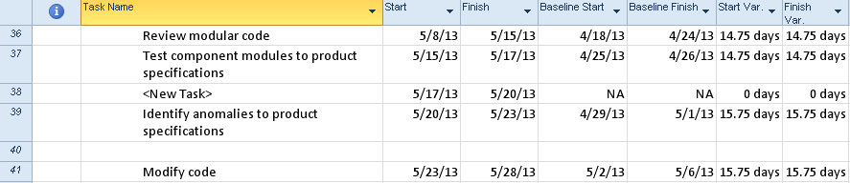
PLACEHOLDER
To delete tasks from the schedule:
Right click the task to be deleted
Click Delete Task option
OR
Click the task to be deleted
Click the Delete key on the keyboard
If you have clicked anywhere within the task row and deleted the task a Smart Tag will appear to ask if you want to clear the field or delete the task.
In the view below the result of clicking on the Smart Tag (the X with the down arrow) is shown. Make your selection from the choices in the box below.
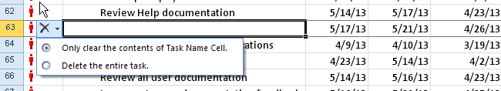
PLACEHOLDER
Project 2010 has the ability to temporarily inactivate a task from the schedule. This is an alternative to deleting a task.
This option is only available in Project 2010 Professional.
The benefits of inactivating tasks as opposed to deleting tasks are:
The task will remain in the schedule and could be reactiated if necessary
The inactive task will not be considered by the scheduling engine.
Relationships will stay in tack and should be removed which will be discussed in next Module 4.
It a task was previously included in the baseline for the project, the data will stay in with the project
If there is a question whether a task should be included it could be entered in an inactive state so it is not forgotten
The inactive task has unique formatting to indicate that it is inactivated.
In the view below task 27 has been inactivated. Note the alternate formatting:
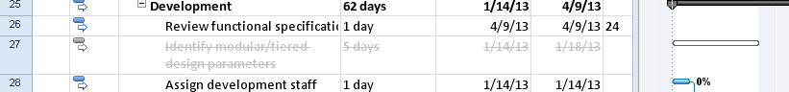
PLACEHOLDER
To inactivate tasks in the schedule:
Click the task
Click Task ribbon → Inactivate in the schedule section
To reactivate an inactivated task:
Click the task
Click Task ribbon → Inactivate in the schedule section
When tasks are entered you will note that the column to the left of the task name is a column called “Task Mode” This column will reflect the default task mode for scheduling of the tasks. By default the task mode is manual, with the other option being automatic. The status of this mode will make a difference in the appearance of the entered task. This is an option that is controlled either on a per task basis or as a preset option as a default of the schedule. We will discuss this new Project 2010 scheduling option in Module 4.
Task Information Form
The Task Information box is a source of easy access for some of the frequently used fields on the task side of the data for a Project 2010 project schedule. Data entered in the form is the same as entering data into a column in a table for a task. Using this box is a quick and easy way to view and maintain task information.
To access the Task Information Form:
Double click an task data field within a task
OR
Click on a task
Task ribbon → Information
The form below will appear:
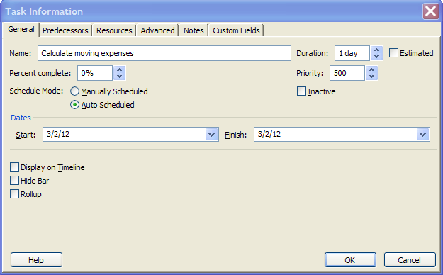
PLACEHOLDER
The form contains several tabs of information, grouped by subject. Each tab will allow access to the Task name, Duration and Estimated flag.
General tab: contains Name, Duration, Percent complete, Priority, Schedule Mode, Inactive, Start and Finish dates, Display on Timeline, Hide Bar and Rollup.
Predecessors: contains information concerning task relationships.
Resources: contains information concerning resources assigned to the task.
Advanced: contains information concerning Deadlines, Constraints, Task Types, Task Calendars, Effort-driven flag, WBS number and Milestone flag for the task.
Notes: general notes area for the task
Custom fields: If task level custom fields (user-defined) were created for the project, they would be accumulated and accessible through this area.
Data may be changed in multiple tasks at the same time. Select the tasks to be changed and then click on the Information icon on the Task bar. The box that appears is called the Multiple Task Information box. Make the changes and click OK to update.
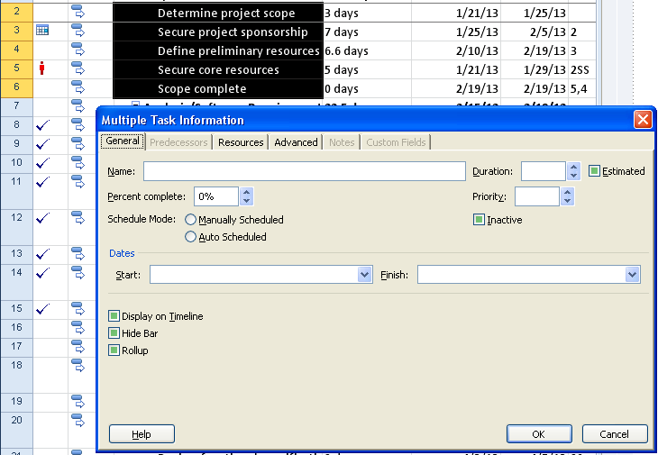
PLACEHOLDER
Outlining Tasks into a Hierarchy
Once tasks are entered, the WBS outline structure may be created. To create the outline structure, tasks will be indented or outdented. These buttons are located on the Task ribbon in the schedule section and are the green arrows in the lower left corner. The indent button is pointing to the right. The outdent button is pointing to the left. See below:
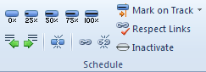
PLACEHOLDER
To indent a task:
Click the task to be indented
Click the indent (pointing right green arrow)
OR
Place the mouse pointer over the task and a horizontal arrow will appear. Left click and drag the task to the right
To outdent a task or remove an indention:
Click the task to be outdented
Click the outdent (left pointing green arrow)
OR
Place the mouse pointer over the task and a horizontal arrow will appear. Left click and drag the task to the left
When a task has an indented task below it, the task becomes a summary task. Summary tasks are represented as black bars on the Gantt chart as shown below:
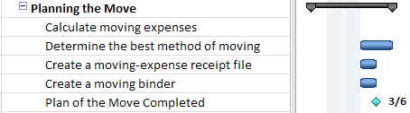
PLACEHOLDER
Indenting and outdenting can be confusing. At times it is difficult to achieve the desired structure results.
When indenting, work from the top down. When outdenting, work from the bottom up.
To see the levels of the WBS:
Project Summary tasks and Summary Tasks will have a small box to the left of the summary task name as seen in the screen above.
Click the plus sign + to expand tasks
Click the minus sign – to collapse tasks
Use the Outline button to jump to a level of detail:
Click on View → Outline:
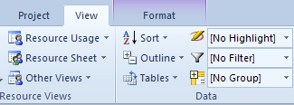
PLACEHOLDER
When the Outline down arrow is clicked, the following choices appear:
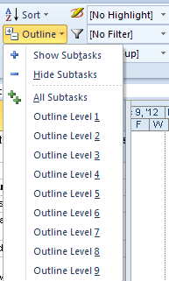
PLACEHOLDER
The following image shows a view of a collapsed WBS – Outline level 1 was selected. Note the rolled up view of the tasks:
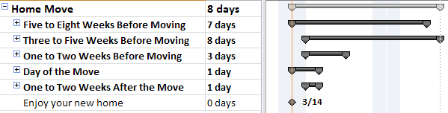
PLACEHOLDER
The following image shows a view of an expanded outline WBS – All Subtasks was selected:
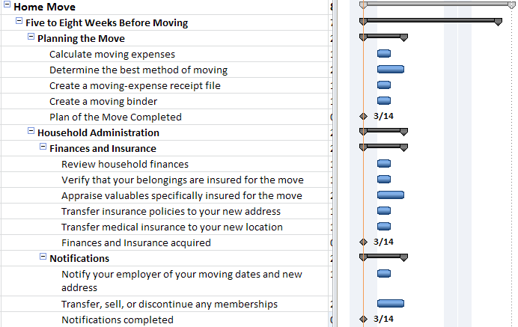
Clicking Project Summary task and then Hide Subtasks will collapse the project down to just the Project Summary task.
If the outline is collapsed, clicking All Subtasks will show all tasks at all levels of the WBS.
The outline list offers the option to create up to 9 WBS levels. There are many more levels available in Project 2010 but it is advised that WBS levels should not exceed 5. The more WBS levels there, the more confusing and cumbersome a WBS may become.
Displaying Outline Numbers & WBS
As the WBS structure is created, an automatic numbering sequence is also created within the task list. The numbers represent where in the WBS structure the tasks reside. This is a unique numbering scheme and numbers are automatically reassigned as tasks are moved around the WBS structure. There are default number values and customized WBS number values. In this lesson, we will address the standard WBS values; the following lesson will address the customized values available.
To view insert the WBS column into a table:
In the Gantt chart view right click on a column heading. It is best to right column in the column to the right of where the new column should be inserted
Select Insert Column
Click the “W” key on the keyboard
Select “WBS”
Click OK
Below is an example of WBS numbering schema:
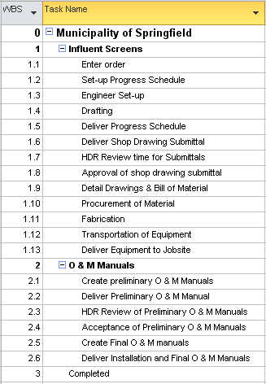
PLACEHOLDER
Because automatic WBS numbers are updated as tasks are moved or added to the WBS, it is not recommended that these numbers be used as a task tracking number. If a task tracking number is desired, consider using the field called “Unique ID”. This field is the order, in which tasks were added to the schedule and they will always be unique and will not be duplicated within a schedule.
Customizing WBS Codes
The user has the option of customizing WBS numbers using a Code Mask and values entered by the user. When this option is evoked, additional options to re-number the WBS, enforce value uniqueness and optinally generate WBSnumbers become available. The customized number values are helpful when manging multiple projects or if there is a need to reference numbers unique to a project schedule. They are also helpful if using templates that result in frequently used task names. These codes could indicate which tasks are members of which project schedules and where the tasks are located within the project schedule.
To customize the WBS numbers:
Project → WBS button → Define
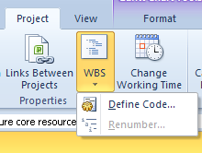
PLACEHOLDER
Project Code Prefix: use this value to enter a code that will represent an abbreviation that applies to all WBSs for the project schedule.
Sequence: select the data type for the Code Mask to be created (ie: Numbers, Uppercase letters, lower case letters or numbers)
Length: number of values for the length of the value
Separator: Character symbol - . , - + or /
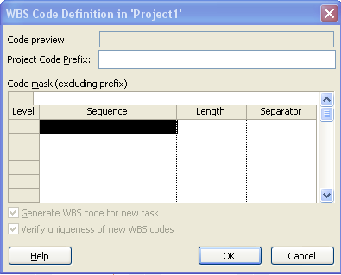
PLACEHOLDER
Select as many lines as necessary to create your “Code Mask” and click OK
Below is an example of a customized mask for WBS codes:
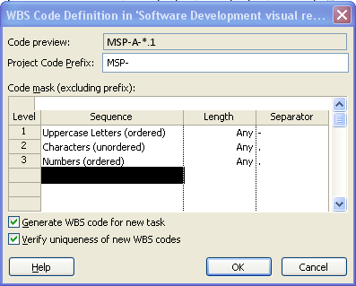
PLACEHOLDER
Below is the result of the customized WBS values:
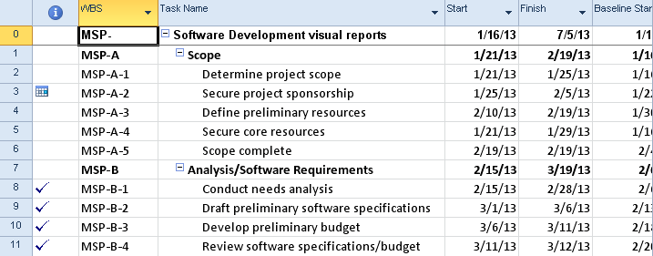
PLACEHOLDER
When a Code Mask is created, the options to Generate a new WBS for a new task and Verify uniqueness of new WBS codes become available.
To renumber the tasks based on the mask values:
Project → WBS → Renumber
Renumbering may be applied to selected tasks only or the entire project.
Be aware:
To remove a mask: delete lower level entries first and work upwards to higher levels.
After removing the mask, the WBS will not revert back to an unformatted state but will remain as the settings for the customized mask.
If WBS values are turned on as part of the task name the original non-formatted value appears and not the customized value. to turn on the WBS value as part of the task name:

From the Gantt Chart click: View → Outline number
The WBS numbers are shown below included with the task names:
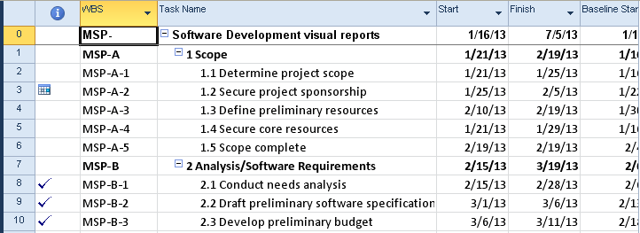
PLACEHOLDER
Best Practices and Standards
By following some guidelines for creating your Work Breakdown Structure, you can achieve a more effective and manageable project schedule. A WBS’s purpose is to help manage a project schedule. When created without guidelines, the project schedule is in danger of becoming another project.
Examples of a few real world project schedules that were not thought out very well:
Consider a two-task project schedule for a 9-month project. Each task was 6 months long. The first task started on the first day of the project. The second task started during the third month of the project. The project manager could not understand why others could not manage their projects using this WBS. It was later discovered the details of the project were brought out at the weekly status meetings and only told to the team members when they needed to know them. The project manager wanted others to help manage their projects was reluctant to share the details. As a result the lack of communication had an adverse effect on the performance of all projects.
A resource was tasked with migrating 1500 users from one email system to another. The project schedule contained 1500 tasks – one for each person who was to be migrated. When asked why each name was entered as a task the answer was that the scheduler wanted to know how long the entire project would take. The project schedule was more of a check list than a WBS. The more appropriate level would have been by department. Creating this type of schedule at a higher level would have made managing the work of the schedule more meaningful and easier to maintain.
A PMO developed a template for their project managers to use while implementing their software packages within organizations that were their clients. Each project implementation took at least a year and each project manager managed 2 to 3 projects simultaneously. The template that was created contained 8500 tasks. The client was not using Project Server and the schedules would need to be updated and maintained manually by the project managers. The PMO created a lot of work for their project managers that would defeat the purpose they were trying to achieve of schedule management. The project schedule they created was a to-do for the projects.
To avoid some of the above problems and pitfalls, consider using some of the following guidelines:
The WBS is not a to-do list. Are you managing tasks or are you managing a to–do checklist? Usually, tasks or deliverables are entered into the project schedule. Checklists of how to accomplish the tasks are kept in another location such as a Word Document, Excel Workbook or SharePoint list. Expect that all tasks will have checklists, supporting detail, resource requirements and activity lists outside of the project schedule. Very small lists may be kept in the notes area of the tasks.
Identify deliverables within the WBS. Work from deliverable to deliverable in the development of the schedule.
Arranging the tasks into summary areas can be a challenge. Imagine a deck of cards: can you arrange them by suit? By color? By number? The deck hasn’t changed, just the order of the cards. There is no right or wrong answers. The answer is what will work best for you to use to manage your project.
Break the deliverables into assignable work. If you are building a house, you might want a task called “Install Electrical” where Electricians can be assigned to the work. This would be a more appropriate level of detail than a task called “Install All Utilities” where Electricians, Plumbers, Carpenters, etc. will all be assigned. When the task is at too high a level, establishing the work, assignments, order and relationships between tasks becomes more difficult.
Establish a standard design for each section of work. An example of this would be:
Summary Task
Detail task
Detail task
Detail task
Milestone task
Using this format will allow for creating high level reports (Milestone reports) easily as well as moving sections of deliverables around easily.
Every summary task should have at least two subtasks. Tasks and milestones can be in the WBS without being part of a summary task grouping.
Establish maximum and minimum lengths of duration for tasks. Create a rule of thumb based on the length of each project. For example: If you have a 6 month project no task should be less than 1 day and no task will be longer than 2 weeks.
Decide if you will be creating a WBS in the rolling wave approach (develop the schedule phases as the project progresses) or a deliverable orientated schedule. The rolling wave type of schedule development is popular for schedules managing software development and other IT orientated project schedules. It can be used for any project where all of the details of the project are not known at the beginning of the project. Alternatively, a deliverable orientated project schedule might have different organizations working on different sections of the project which all need to be completed at a specific point in time. For example: building heavy equipment. Each section of the machinery might be built by separate organizations, but all pieces must be ready for assembly by the same target date.
Deliverables: Completing a section of work means that the deliverable of that section has been accepted. Create a task for the delivery of the deliverable and create a milestone to represent the acceptance of the deliverable. The two are rarely occur at the same time.
Level of detail. Project 2010 will allow for a maximum of 99 levels of WBS details. Best practices for level of detail is to develop schedules at five or less levels. If a WBS were built 20 levels deep, this would mean the project manager would have to dig through 20 levels of titles before uncovering the work of the project.
If too much detail is put into the project schedule, the schedule will become a project unto itself. In the third example above, the WBS was a check list and not based on tasks to manage. Schedules will be tracked and tasks will change over the course of the project all of which will require the project manager’s attention. The more tasks, the more work.
Use the WBS to help manage the scope of your project. If the task isn’t in the project, consider it out of scope. When you enter tasks into the project schedule, ask yourself if the task is necessary.
When planning the WBS think about just the work of the project. Many project managers like to start thinking about who will do the work and when. It is a good idea to focus on the work of the project only and think of the work as the “what” of the project. The “who” and “when” will come as the project schedule develops.
Having the project team or the top level resources help build the WBS for a project is a win-win for the project:
Increases resource buy in
Encourages resource contribution
Many eyes looking at problems from different angles
Less probability of missing tasks
Encourages team building
Enter Tasks
Project Summary Task
Milestones
A milestone is a check point in your project. It is a status, not a task which means that it has no duration and no resources are needed. For example, an approval or sign-off before the project can proceed and the completion of a stage of the project are both milestones. To Project, a milestone is a task with a zero duration.
To enter a milestone, use the following steps:
Insert a new task, or click the Task Name of a blank task.
Type the name for the milestone in the Task Name field and press the Tab key.
Type “0” in the Duration field, and press the Enter key.
Milestones are denoted in the Gantt Chart as a diamond symbol, rather than a bar (since the milestone has no duration).
Indenting
Type in Tasks
Entering tasks into Project 2010 is as easy as typing the task name into the Task Name field. When entering a new task, keep in mind that data is being populated in an array of fields for that row; several hundred fields will be created and some populated. After tasks are entered they may be moved, deleted, or copy/pasted to other areas of the schedule. It is also recommended that the Project Summary Task be turned on to aid in schedule development.
To turn on the Project Summary task:
Click on Format → Project Summary Task (In the show/hide section on the right)
Click the check box to turn on
To enter a new task:
Click the Task Name field on the row you would like to enter and type the task name.
To move a task to another location in the schedule:
Left Click on the task number (ID) in the left column. Hold the click down and wait for the 4 way arrow to appear and drag to the task to the new location. (Works well when the new location can be seen on the screen)
OR
Click on the task number of the task you wish to move
Click copy (or cut)
Scroll to the new location
Click Paste – Project 2010 will insert the pasted task
Entering blank lines to receive the moved tasks is not necessary. The schedule will insert the lines and move tasks down to accommodate the moved tasks.
To add blank lines schedule between existing tasks:
Right click on the task below the location of the new task to be inserted
Click Task → Task – a blank row will be created above the task selected
OR
Click on a task
Click Insert key on the keyboard
In the view below task 38 was entered using the Task → Task insert method. Note the default data and <New Task> name entered. Task 40 was the result of clicking the Insert key on the keyboard.
PLACEHOLDER
To delete tasks from the schedule:
Right click the task to be deleted
Click Delete Task option
OR
Click the task to be deleted
Click the Delete key on the keyboard
If you have clicked anywhere within the task row and deleted the task a Smart Tag will appear to ask if you want to clear the field or delete the task.
In the view below the result of clicking on the Smart Tag (the X with the down arrow) is shown. Make your selection from the choices in the box below.
PLACEHOLDER
Project 2010 has the ability to temporarily inactivate a task from the schedule. This is an alternative to deleting a task.
This option is only available in Project 2010 Professional.
The benefits of inactivating tasks as opposed to deleting tasks are:
The task will remain in the schedule and could be reactiated if necessary
The inactive task will not be considered by the scheduling engine.
Relationships will stay in tack and should be removed which will be discussed in next Module 4.
It a task was previously included in the baseline for the project, the data will stay in with the project
If there is a question whether a task should be included it could be entered in an inactive state so it is not forgotten
The inactive task has unique formatting to indicate that it is inactivated.
In the view below task 27 has been inactivated. Note the alternate formatting:
PLACEHOLDER
To inactivate tasks in the schedule:
Click the task
Click Task ribbon → Inactivate in the schedule section
To reactivate an inactivated task:
Click the task
Click Task ribbon → Inactivate in the schedule section
When tasks are entered you will note that the column to the left of the task name is a column called “Task Mode” This column will reflect the default task mode for scheduling of the tasks. By default the task mode is manual, with the other option being automatic. The status of this mode will make a difference in the appearance of the entered task. This is an option that is controlled either on a per task basis or as a preset option as a default of the schedule. We will discuss this new Project 2010 scheduling option in Module 4.
Outline Levels
The schedule is listed in a hierarchical format in the Entry table. This is a visual cue as to the grouping of tasks within the project. If you have a large project, you can group certain related tasks together under summary tasks to define the major phases of your project. For example, if you have five tasks in your project that are all related to writing, you can group them under a summary task called “Writing.” The tasks under a summary task are called subtasks.
Summary tasks appear in bold type, while the individual subtasks appear under the Summary task.
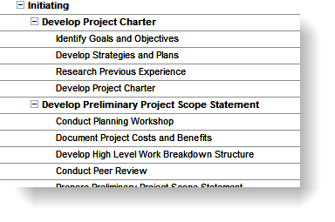
Task List
Indenting and Outdenting Tasks
Indenting and outdenting tasks provides a way to create an effective outline structure. The outline format allows you to control the level of detail Project displays. You can display every task in your project, or you can display only the summary tasks. Project allows you to have multiple outline levels in your project, as you would in a complicated report or paper.
When you indent one or more tasks, Project demotes each of the selected tasks one level, converts the task immediately above the first selected task into a summary task, and changes the duration of the summary task to reflect the total (rolled up) duration of the subtasks.
When you outdent one or more tasks, Project promotes the task one level.
As tasks are entered into the Entry table, the task will inherit the level of indenting of the previous task. Tasks can be indented or outdented as needed to create the level of hierarchy needed.
To indent a task:
Select a task in the Entry table.
On the Task tab, Schedule group, click the green arrow pointing to the right. Repeat clicking the green arrow icon to continue to move the task to the desired indent level.
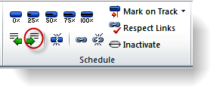
Indenting a Task
To outdent a task:
Select a task in the Entry table.
On the Task tab, Schedule group, click the green arrow pointing to the left. Repeat clicking the green arrow icon to continue to move the task to the desired indent level.
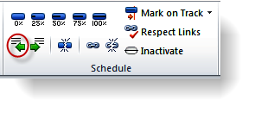
Outdenting a Task
Collapsing and Expanding the Outline
One of the main benefits of outlining is that you can control the level of detail that Project displays. For example, if you want to inform upper management about the status of your project, they may not be interested in the daily tasks, only the major phases. You can collapse the outline to display only summary tasks, you can expand the outline to display all of the tasks, or you can display the subtasks for some summary tasks, but not for others.
The boxes containing plus (+) or minus (-) signs to the left of the summary tasks are called outline boxes. If an outline box contains a plus sign, it means that the summary task has subtasks under it and can be expanded. If an outline box contains a minus sign, it means that the summary task is expanded and can be collapsed.
To collapse the schedule outline:
Select the desired Summary task.
Click the minus (-) sign icon to the left of the Summary task.
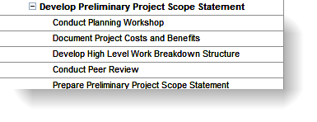
Minimize a Summary Task
To expand the schedule outline:
Select the desired Summary task.
Click the plus (+) sign icon to the left of the Summary task.
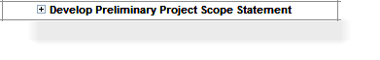
Expand a Summary Task
Project provides a Ribbon icon to quickly change the indent level viewing for the schedule. This action will apply the outline level to the complete schedule.
To view different outline levels:
In the View tab, Data group, click the Outline dropdown arrow and select the desired outline level to view.
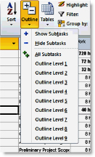
Outline Dropdown Menu
Moving and Copying Tasks
If you want to create a task that is similar to an existing task, you can copy the existing task and then modify the copy. If you copy a task either from or into a list of tasks linked with Finish to Start relationships, Project inserts the task and adjusts the links so the original tasks remain sequential.
To copy a task:
Select the entire row of the task you want to copy by clicking on its ID field. If you only want to copy one field, such as the task name, select only that field.
In the Task Tab, Clipboard group, click Copy. Project copies the task to the Clipboard.
Select the task below the line the task will be inserted.
In the Task tab, Clipboard group, click Paste.
Keyboard shortcuts Ctrl+C (copy) and Ctrl+V (paste) will work as well.
You can also copy a single cell of data, rather than the entire task row.
Be aware that when you paste the contents of a single field, Project overwrites the contents of the field into which you paste. If you paste the single field into a blank row, Project creates a new task.
To move a task:
Click the ID number of the task to select the entire row.
Drag the entire task to the new location, between two existing tasks.
If you drag the contents of a single field to another field, Project overwrites the contents of the field.
If you move a task that is within a series of tasks that are linked sequentially, Project automatically adjusts the link relationships of the remaining tasks to reflect the new task order. Project does this only if the current task is linked to the task directly above and below. The moved task will maintain the original link to predecessors. Linking to a new series will need to be done manually.
Copy, Delete, Edit, Insert, etc.

Move Around

WBS Code Field
As the WBS structure is created, an automatic numbering sequence is also created within the task list. The numbers represent where in the WBS structure the tasks reside. This is a unique numbering scheme and numbers are automatically reassigned as tasks are moved around the WBS structure. There are default number values and customized WBS number values. In this lesson, we will address the standard WBS values; the following lesson will address the customized values available.
To view insert the WBS column into a table:
In the Gantt chart view right click on a column heading. It is best to right column in the column to the right of where the new column should be inserted
Select Insert Column
Click the “W” key on the keyboard
Select “WBS”
Click OK
Below is an example of WBS numbering schema:
PLACEHOLDER
Because automatic WBS numbers are updated as tasks are moved or added to the WBS, it is not recommended that these numbers be used as a task tracking number. If a task tracking number is desired, consider using the field called “Unique ID”. This field is the order, in which tasks were added to the schedule and they will always be unique and will not be duplicated within a schedule.
Manual vs Automatic
Intro and the Basics
Project 2010 provides two scheduling methods for creating project schedules. The methods are the traditional or automatic scheduling and manual scheduling.
Traditional or automatic scheduling
This scheduling method was used in prior versions of MS Project and is contained in Project 2010. After tasks are entered relationships or dependencies are created between the tasks. The task durations with their relationships established the timeline for the schedule. This scheduling method allows for bottom up scheduling where the sum of the detail tasks establishes the time line for the project.
Manual scheduling
Manual scheduling allows for top-down scheduling where summary tasks may be added first and the details of the project work is completed later. It also permits more unknowns during scheduling process and the ability to complete the details when known. Tasks do not have to contain relationships and scheduling dates may be entered.
Project scheduling mode will be selected on a task by task basis. Manually scheduled tasks and automatic scheduled tasks may be mixed within the same project schedule. Each task will contain a column called task mode which will establish the scheduling mode assigned to a task.
When to Use Manual vs. Automatic Scheduling
Manual vs. automatic scheduling usage is a personal preference. The project manager’s schedule management expectations, experience and goals will be included when deciding to use one method over the other. The amount of information concerning the project that is available to the scheduler when the schedue is created should also be taken into consideration. It may be advantageous to use both scheduling methods within a schedule switching between scheduling methods when needed.
Use Manual scheduling when:
Minimal information is available about the project and you need to put your ideas into an initial schedule.
Tasks are assigned to specific dates and you are not comfortable with the schedule moving as other tasks are entered or as resources are assigned.
Using top-down planning – entering duration values for summary tasks followed by detail tasks and milestones to complete the work of the summary tasks.
Using free form planning of tasks and durations to produce a Gantt chart.
Need to build a rough schedule for a future project
Relationships are not known.
Manual scheduling is your most preferred method. Enter as many durations, relationships and dependencies as you need to help establish the timeline. This will help with critical path calculation as well.
Use Automatic scheduling when:
More complete information is known about the goals of the project.
Using bottom up planning. Enter the summary tasks names only. The detail tasks within the summaries will calculate the duration of the summary tasks.
You want the schedule to be dynamic. Tasks will be re-scheduled based on work completed and associated dependencies. The scheduling engine will help keep you on track for the project and help you manage to an end date.
You want the scheduling engine to calculate dates in the schedule.
Resource allocations, earned value and more accurate metrics are needed.
Consider using a combination of both methods when:
Initial planning could be in manual mode. As decisions are made and more detail is known, tasks may be converted to automatic mode.
Consider converting to automatic mode when project execution begins. This may be done for the entire project, by phase or range of tasks.
Project files from earlier Project versions:
When Project 2010 opens projects schedules created in earlier versions tasks will be locked in automatic mode and the mode can not be altered unless they are upgraded to a Project 2010 file.
Saving the file with a new name converts the file to a Project 2010 file and the automatic/manual mode option becomes available.
The Type Mode field might not be visable when opening projects of earlier versions. When attempting to insert the Task Mode column into a table, the column will not be available.
Basic Discussion
Project Live Cycle Approach

